|  |
| --- |
| **National University of Computer and Emerging Sciences** |
| Lab Manual 8  “SQL Agents and JOBS” |
|  |
| Database Systems |
| Spring 2018 |

Department of Computer Science

FAST-NU, Lahore, Pakistan

# Sql Agents

SQL agent, also known as SQL server agent, is a Microsoft SQL server relational database management system (RDBMS) background tool. SQL agent allows the database administrator (DBA) to schedule automated execution jobs, as well other management or value-added database tasks such as backups.

SQL agent is an integral part of Microsoft’s SQL Server. It runs as a windows service only and allows for the handling of a wide variety of tasks such as backup automation, database replication setup, job scheduling, user permissions and database monitoring.

These tasks do not necessarily have to be related to SQL Server. For example, a daily backup job may be created to use a database backup to call an external program (e.g., WinZip) to compress the backup file result, and then relocate the file by invoking the MOVE command.

SQL agent jobs are a series of steps that use a graphical user interface (GUI) wizard, allowing DBAs at every experience level to set up jobs comprised of a complex series of tasks. After setting up a job, the DBA can schedule an execution frequency; for example, it could be one-time only, daily, weekly or monthly.

# Job Response

Job responses specify actions that the SQL Server Agent service will take after a job completes. Job responses ensure that database administrators know when jobs complete and how frequently they run. Typical job responses include:

* Notifying the operator by using e-mail, electronic paging, or a **net send** message.

Use one of these job responses if the operator must perform a follow-up action. For example, if a backup job completes successfully, the operator must be notified to remove the backup tape and store it in a safe location.

* Writing an event message to the Windows application log.

You can use this response only for failed jobs.

* Automatically deleting the job.

Use this job response if you are certain that you do not need to rerun this job.

# Creation of a Job

To create a SQL Server Agent job

Execute sp_add_job to create a job.

Execute sp_add_jobstep to create one or more job steps.

Execute sp_add_schedule to create a schedule.

Execute sp_attach_schedule to attach a schedule to the job.

Execute sp_add_jobserver to set the server for the job.

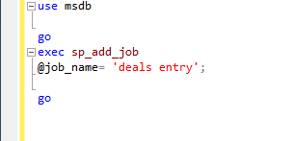

It can be seen that rather than using the database for which the job is being created we are using msdb because job is an sql server agent. It can also be seen that in the step given in the figure only the name of the job is defined not what it would do.

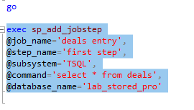

Now in the figure given above, you can see that we have finally given the name of the database that must contain the job in question and in the @command argument, we have given the command we want to execute.

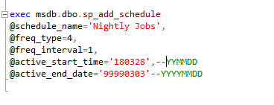

Now this figure shows the addition of a schedule to a given job but even this is not enough to run the procedure daily. We have to attach the schedule to the job.



Now the schedule “Nightly Jobs” schedule has been attached to the job “deals entry”.

Now the job “deals entry” will run automatically run daily.